Procedures to file a request to IP Viet Nam (Intellectual Property Office of Viet Nam) for Patent Prosecution Highway Pilot Program between IP Viet Nam and JPO (Japan Patent Office)

Applicants can request accelerated examination by a prescribed procedure including submission of relevant documents for an application which is filed with IP Viet Nam based on a JPO application and satisfies the following requirements under the IP Viet Nam-JPO Patent Prosecution Highway (PPH) pilot program.
When filing a request for the PPH pilot program, applicants must submit a request form to IP Viet Nam.
The Offices may terminate the PPH pilot program if the volume of PPH request exceeds 200 per year (in which up to 100 PPH requests for the period from 1st April to 30th September and the rest out of 200 PPH requests for the period from 1st October to 31st March of the following calendar year), or for any other reason. An ex Ante notice will be published if the PPH pilot program is terminated.
Upon request of either Office, this document can be revised any time during the PPH pilot program if necessary.

The PPH pilot program will be in effect for three years commencing on April 1, 2022 and will end on March 31, 2025. However, the pilot program may be extended after a joint IP Viet Nam-JPO review and assessment of the program implementation.

1. Requirements
- The IP Viet Nam application (including a PCT national phase application) is
  - an application which validly claims priority under the Paris Convention to the JPO application(s) (examples are provided in ANNEX, Figure A, B, C, F, G and H), or
  - a national phase application of a PCT application without priority claim filed at JPO as receiving office (the application number begins with PCT/JP, hereafter referred to as PCT/JP application) (examples are provided in ANNEX, Figure I), or
  - an application which validly claims priority under the Paris Convention to a PCT/JP application(s) referred to in (ii) above (examples are provided in ANNEX, Figure J, K and L).
The IP Viet Nam application, which validly claims priority to multiple JPO or direct PCT applications, or which is the divisional application validly based on the originally filed application that is included in (i) to (iii) above, is also eligible.
The pilot program is not applicable on the basis of JPO ‘utility model’ applications.

(b) At least one corresponding application exists in JPO and has one or more claims that are determined to be patentable/allowable by JPO.
The corresponding application(s) can be the application which forms the basis of the priority claim, an application which derived from the JPO application which forms the basis of the priority claim (e.g., a divisional application of the JPO application or an application which claims domestic priority to the JPO application (see Figure C in Annex), or an JPO national phase application of a PCT application (see Figures H, I, J, K and L in Annex).
Claims are “determined to be allowable/patentable” and do not suffer from any deficiencies related to unity, clarity, support by description when the JPO examiner clearly identified the claims to be allowable/patentable in the latest office action, even if the application is not granted for patent yet.
The office action includes at least one of the following:
(a) Decision to Grant a Patent
(b) Notification of Reasons for Refusal
(c) Decision of Refusal
(d) Appeal Decision
For example, if the following routine expression is described in the “Notification of Reason for Refusal” of JPO, those claims are clearly identified to be allowable/patentable.
“<Claims which has been found no reason for refusal>
At present for invention concerning Claim__, no reason for refusal is found.”

(c) All claims on file, as originally filed or as amended, for examination under the PPH must sufficiently correspond to one or more of those claims indicated as allowable in JPO.
Claims are considered to “sufficiently correspond” where, accounting for differences due to translations and claim format, the claims in IP Viet Nam are of the same or similar scope as the claims in JPO, or the claims in IP Viet Nam are narrower in scope than the claims in JPO. In this regard, a claim that is narrower in scope occurs when a JPO claim is amended to be further limited by an additional feature that is supported in the specification (description and/or claims).
A claim in IP Viet Nam which introduces a new/different category of claims to those claims indicated as allowable in JPO is not considered to sufficiently correspond. For example, where the JPO claims only contain claims to a process of manufacturing a product, then the claims in IP Viet Nam are not considered to sufficiently correspond if the IP Viet Nam claims introduce product claims that are dependent on the corresponding process claims.
Any claims amended or added after the grant of the request for participation in the PPH pilot program need not to sufficiently correspond to the claims indicated as allowable in the JPO application.

(d) IP Viet Nam has not begun examination of the application at the time of request for the PPH (an example is provided in ANNEX, figure M).

(e) A “Request for Substantive Examination” must have been filed at IP Viet Nam either at the time of the PPH request or previously.

2. Documents to be submitted
Documents (a) to (d) below must be submitted by attaching to the PPH request.

- Copies of all office actions (which are relevant to substantial examination for patentability in JPO) which were issued for the corresponding application by JPO, and translations of them.
Either Vietnamese or English is acceptable as translation language. The applicant does not have to submit a copy of JPO office actions and translations of them when those documents are provided via AIPN (JPO’s dossier access system) because the office actions and their machine translations are available for the IP Viet Nam examiner via the AIPN. If they cannot be obtained by the IP Viet Nam examiner via the AIPN, the applicant may be notified and requested to provide the necessary documents.

- Copies of all claims determined to be patentable/allowable by JPO, and translations of them¹.
Either Vietnamese or English is acceptable as translation language. The applicant does not have to submit a copy of claims indicated to be allowable/patentable in JPO, and translations thereof when the documents are provided via AIPN (JPO’s dossier access system) because they are available for the IP Viet Nam examiner via the AIPN. If they cannot be obtained by the IP Viet Nam examiner via the AIPN, the applicant may be notified and requested to provide the necessary documents.

- Copies of references cited by the JPO examiner
If the references are patent documents, the applicant doesn’t have to submit them because IP Viet Nam usually possesses them. When IP Viet Nam does not possess the patent document, the applicant has to submit the patent document at the examiner’s request. Non-patent literature must always be submitted.
The translations of the references are unnecessary.

- Claim correspondence table
The applicant requesting PPH must submit a claim correspondence table, which indicates how all claims in the IP Viet Nam application sufficiently correspond to the patentable/allowable claims in the JPO application.
When claims are just literal translation, the applicant can just write down that “they are the same” in the table. When claims are not just literal translation, it is necessary to explain the sufficient correspondence of each claim.
When the applicant has already submitted above documents (a) to (d) to IP Viet Nam through simultaneous or past procedures, the applicant may incorporate the documents by reference and does not have to attach them.

3. Procedure for the accelerated examination under the PPH pilot program

IP Viet Nam decides whether the application can be entitled to the status for an accelerated examination under the PPH when it receives a request with the documents stated above. When IP Viet Nam decides that the request is acceptable, the application is assigned a special status for an accelerated examination under the PPH.
In those instances where the request does not meet all the requirements set forth above, the applicant will be notified and the defects in the request will be identified. Before the issue of the notification of not assigning a special status for accelerated examination under the PPH, the applicant will be given opportunity to submit missing documents. Even after the issue of the notification of not assigning a special status for accelerated examination under the PPH, the applicant can request the PPH again.
4. IP Viet Nam – JPO PPH request form

REQUEST FOR PARTICIPATION IN
THE PATENT PROSECUTION HIGHWAY (PPH) PILOT PROGRAM
- Bibliographic Data
Application Number (if known)
Applicant’s name
Title of invention
- Request
Applicant requests participation in the Patent Prosecution Highway (PPH) pilot program based on:
Office of Earlier Examination (OEE)
OEE Work Products Type |  |  |  | □ National/Regional Office Action(s)
OEE Application Number
Priority Application Number (see 1.i) or PCT Application Number (see 1.ii; 1.iii)
- Required Documents
I. OEE Work Products and, if required, Translations
- □ A copy of OEE work products is attached; or
□ The office is requested to retrieve documents via the Dossier Access System or PATENTSCOPE
- □ A translation of documents in 1 in a language accepted by the Office is attached; or
□ The office is requested to retrieve documents via the Dossier Access System or PATENTSCOPE
II. Patentable/Allowable Claims Determined by OEE and, if required, Translations
- □ A copy of all claims determined to be patentable/allowable by OEE is attached; or
□ The office is requested to retrieve documents via the Dossier Access System or PATENTSCOPE
- □ A translation of documents in 3 in a language accepted by the Office is attached; or
□ The office is requested to retrieve documents via the Dossier Access System or PATENTSCOPE
III. Documents Cited in OEE Work Products (if required)
- □ A copy of all documents cited in OEE work products is attached (excluding patent documents); or
□ no references cited
IV. Previously submitted documents
- □ If any of the above mentioned documents have been submitted before, please specify:
- Claims Correspondence
□ All the claims in the application sufficiently correspond to the patentable/allowable claims in the OEE application; or
□ Claims correspondence is explained in the following table
Application Claims | Corresponding OEE claims |  |  |  | Explanation regarding the correspondence
Name(s) of applicant(s) or representative(s)
Date

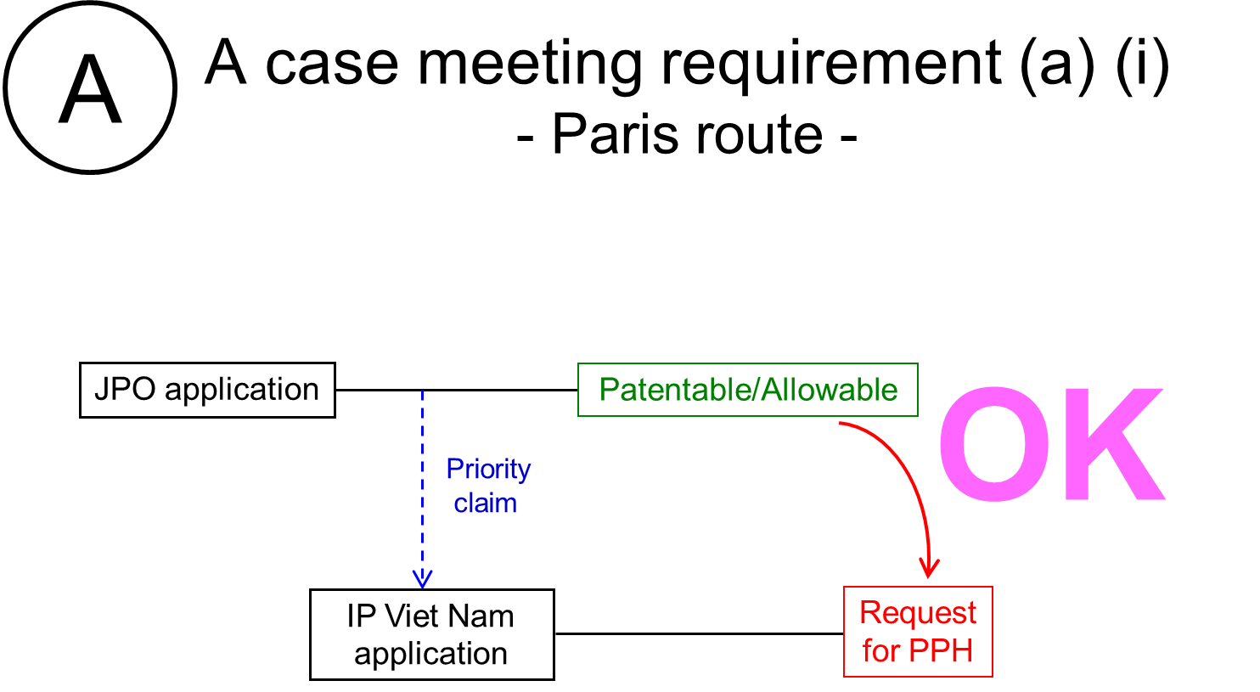

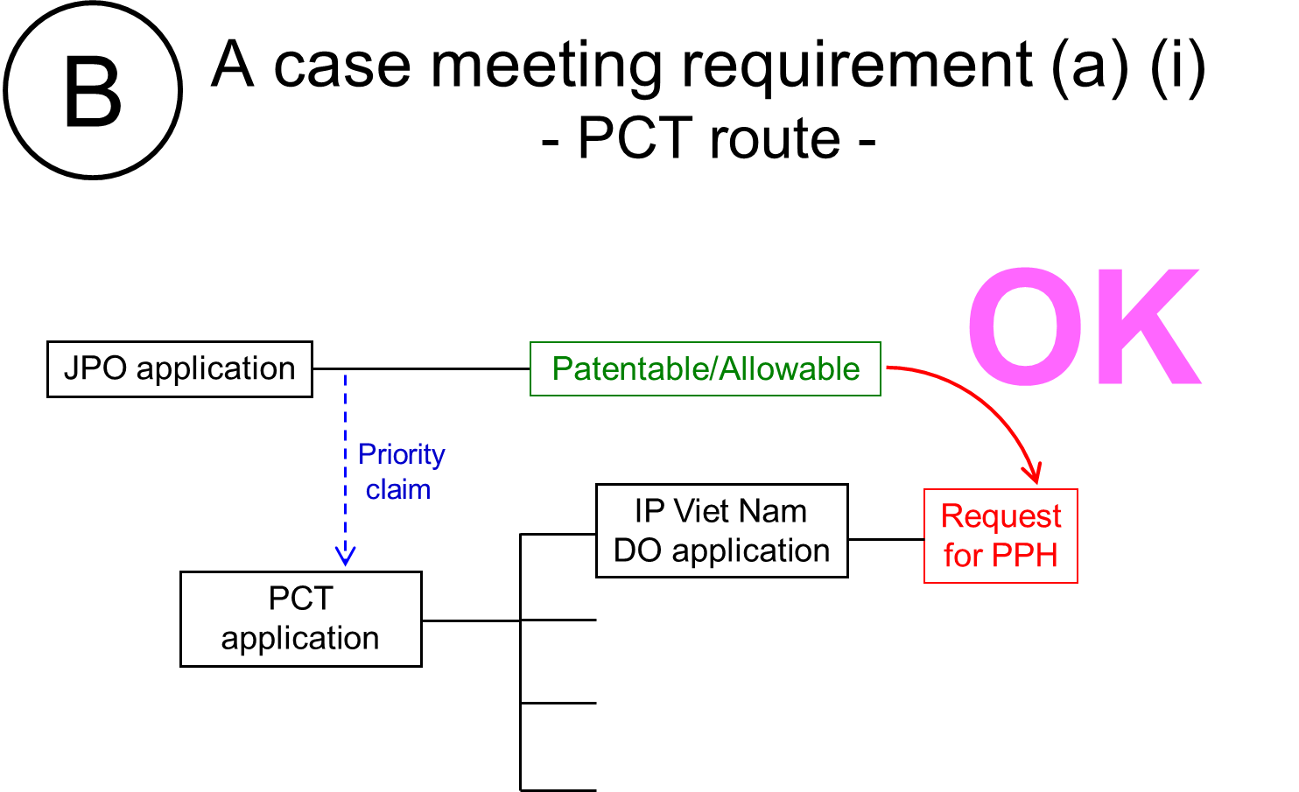
IPVN

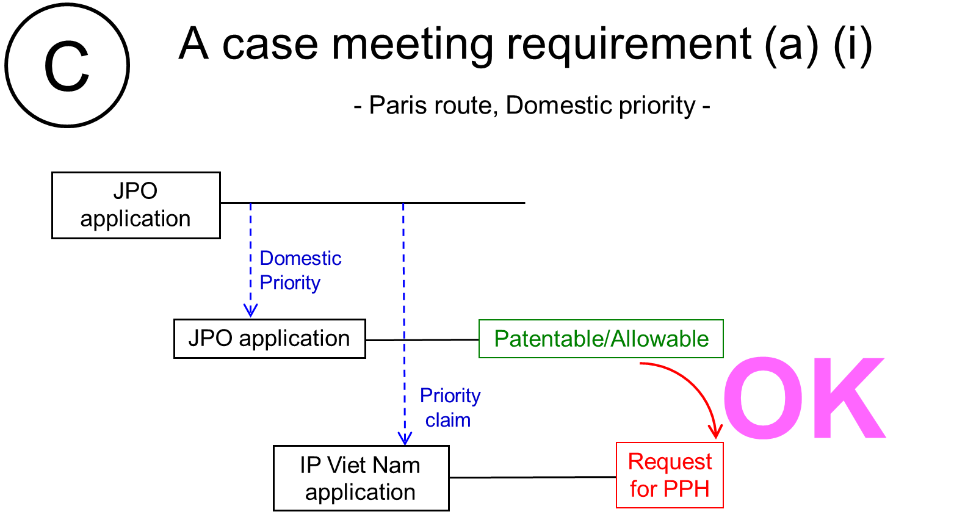

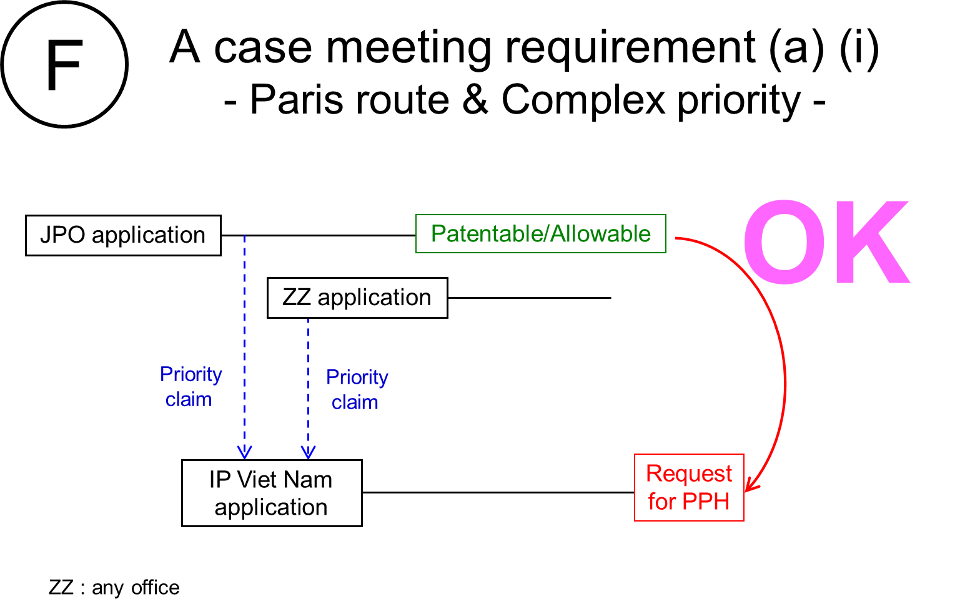

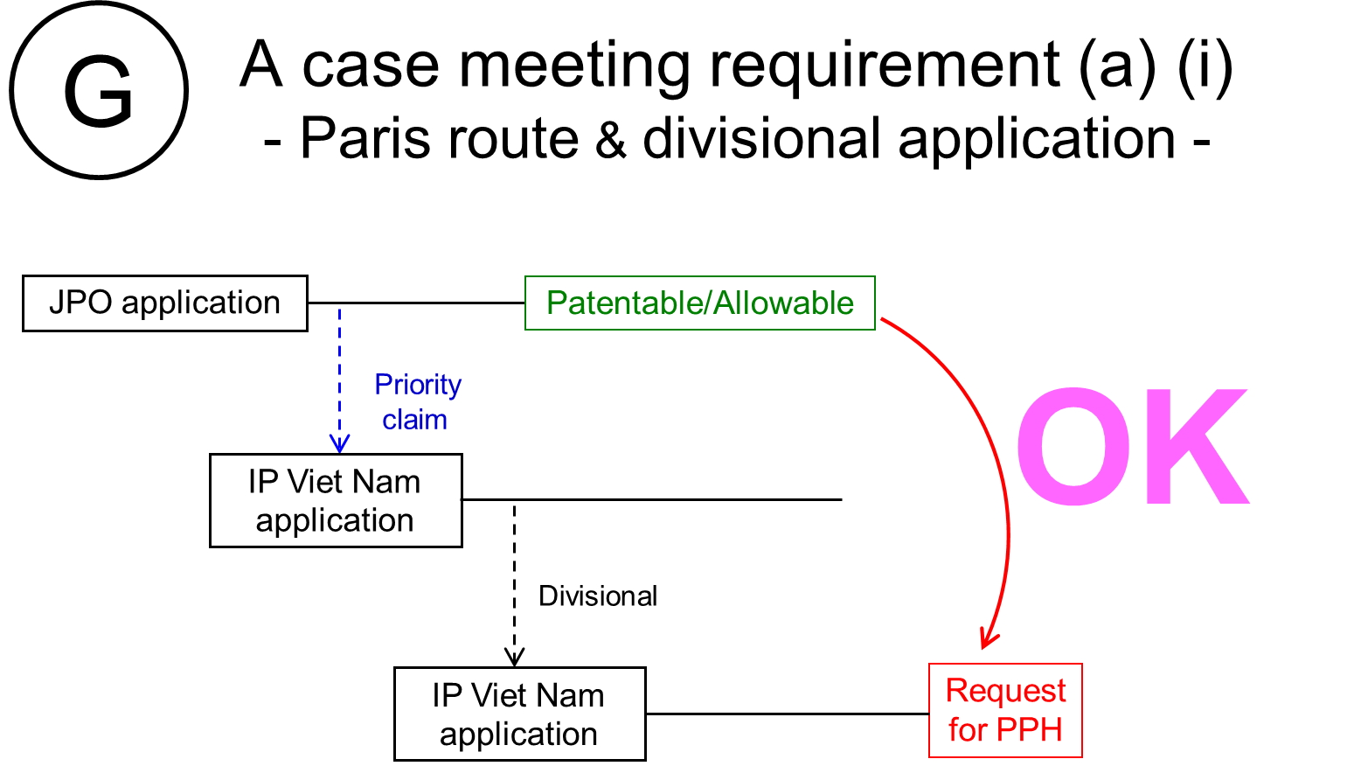
IPVN
IPVN

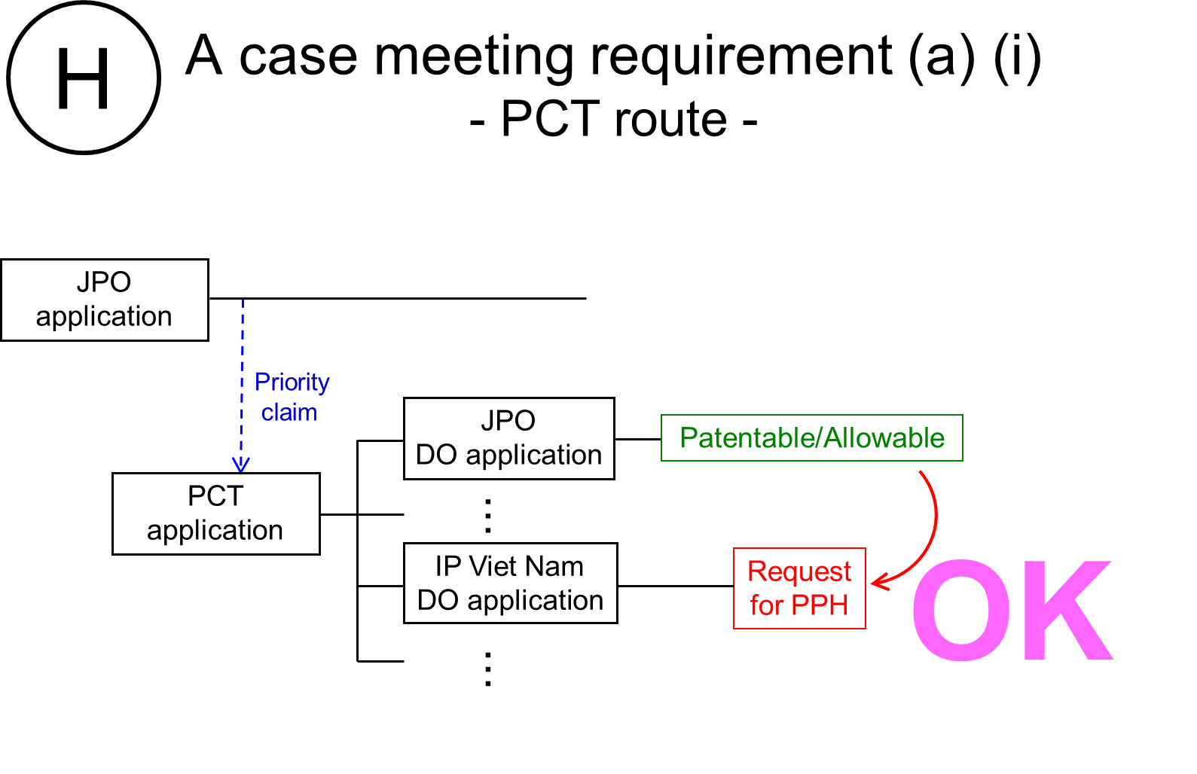

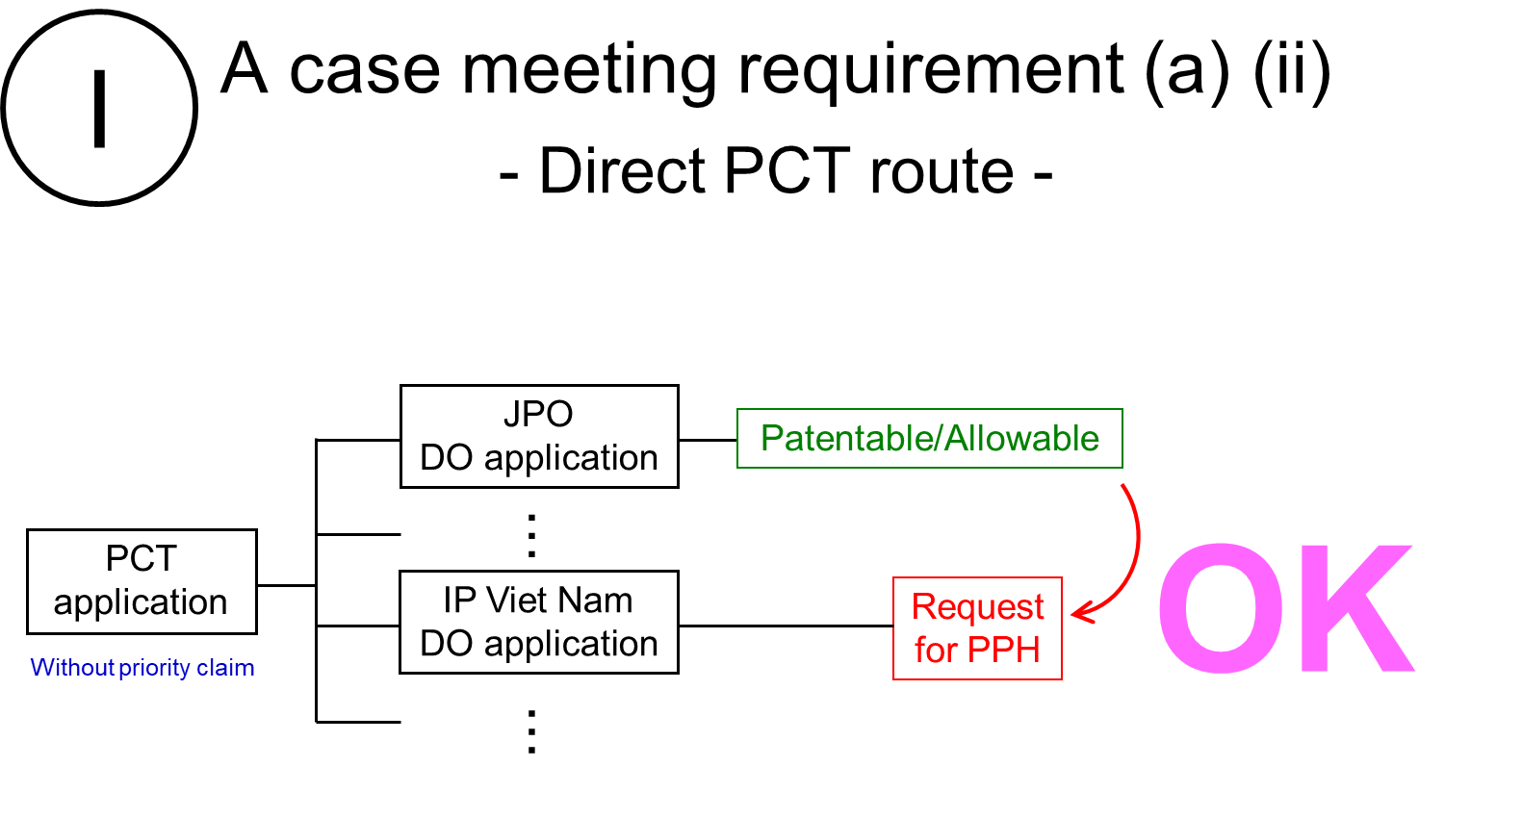

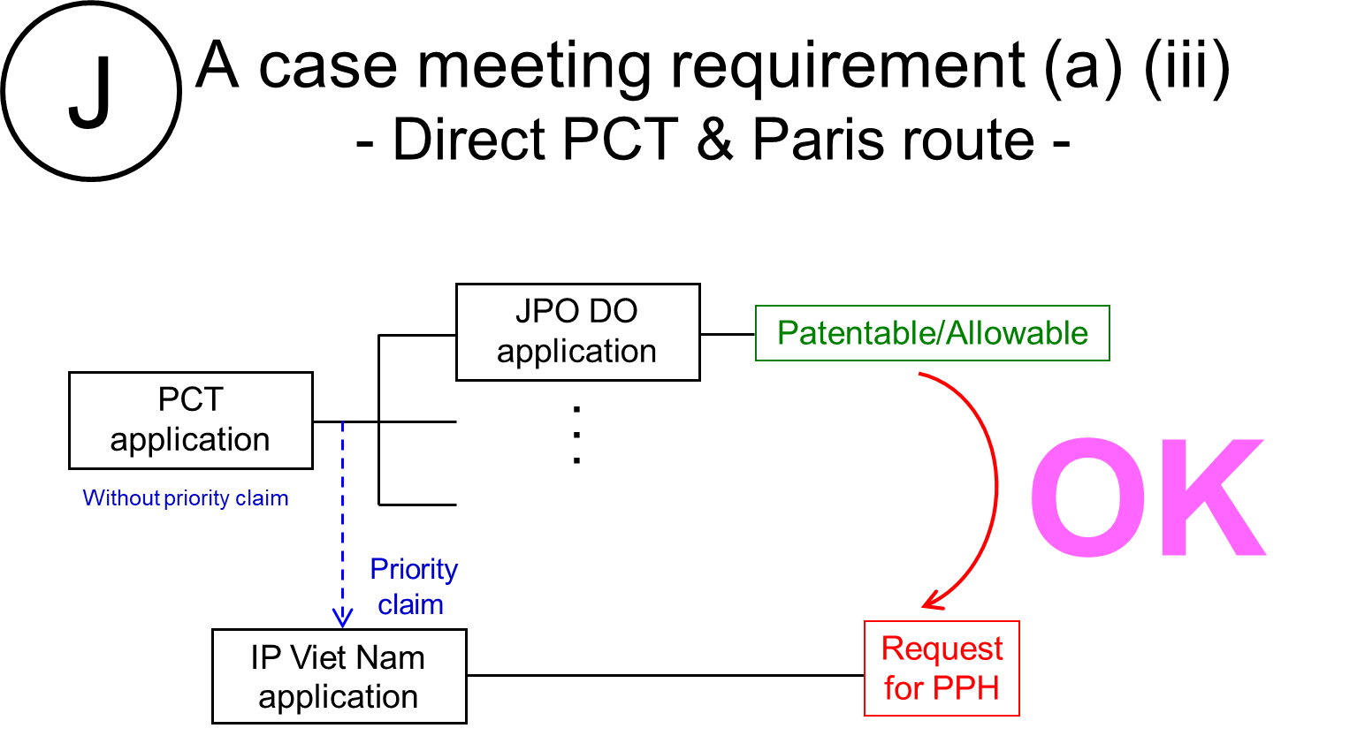

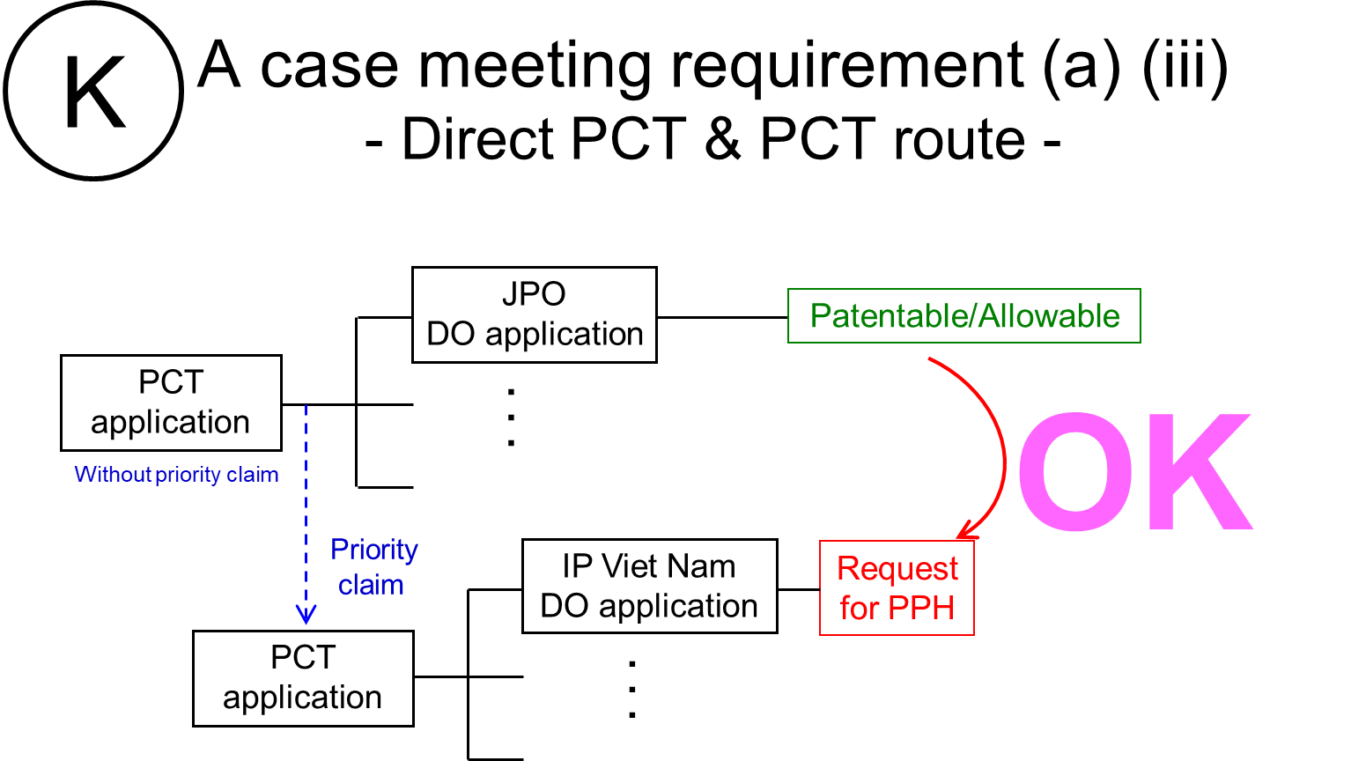

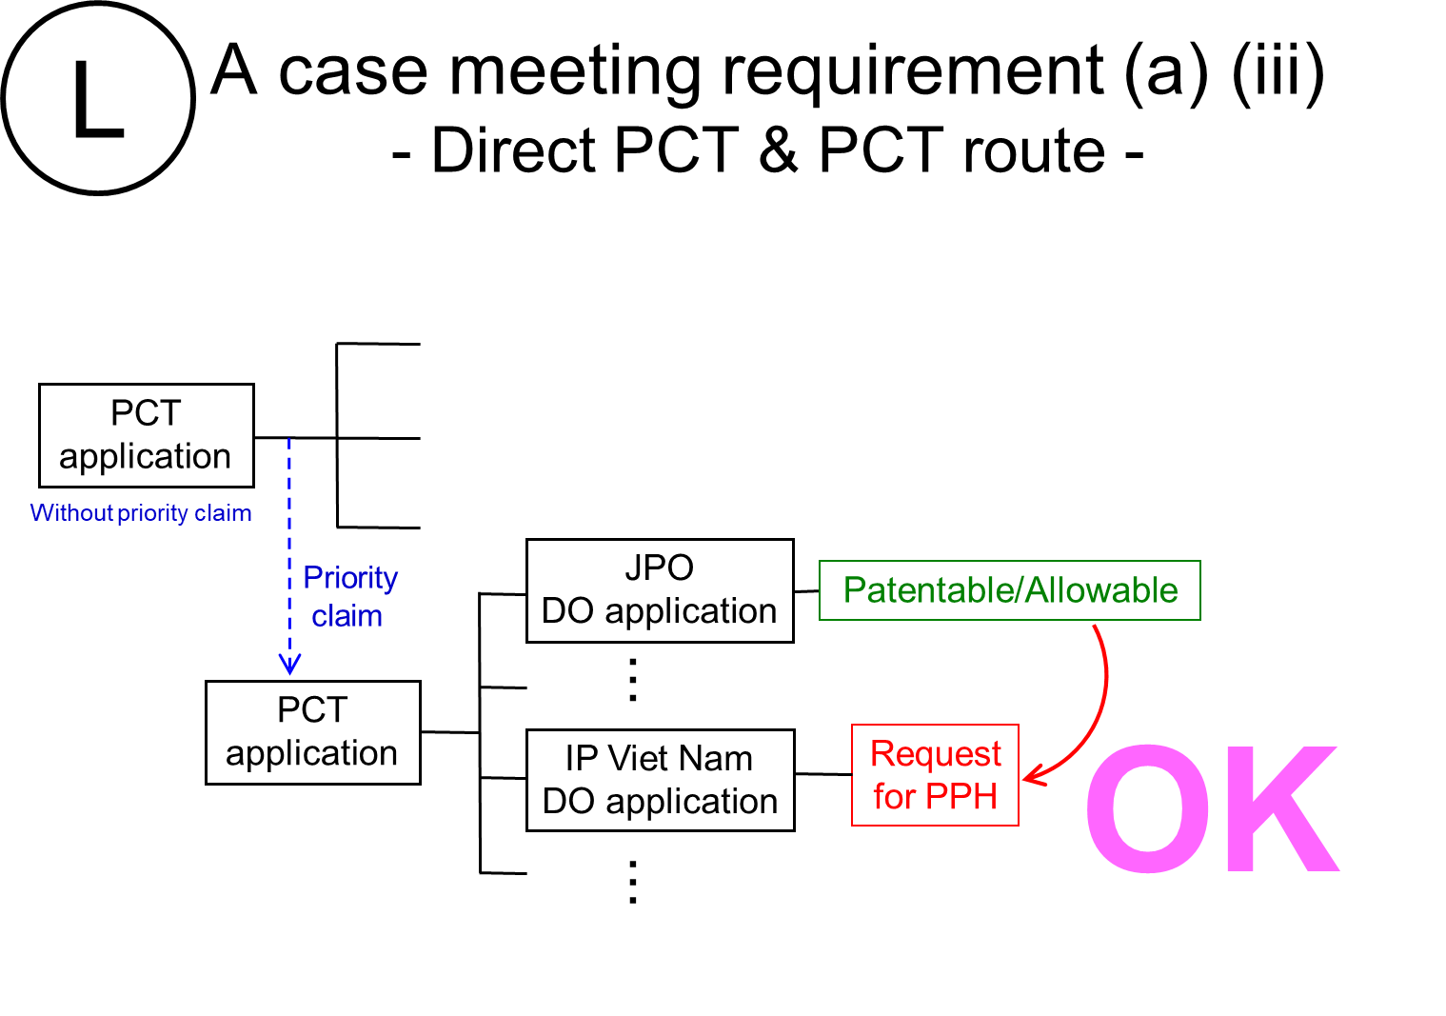

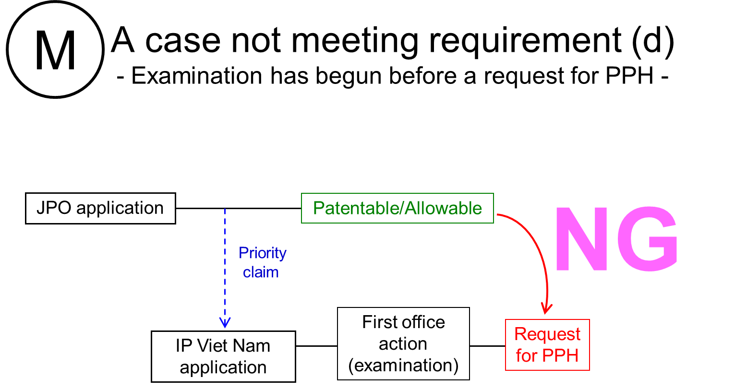

Machine translations will be admissible, but if it is impossible for the examiner to understand the outline of the translated office action or claims due to insufficient translation, the examiner can request the applicant to resubmit translations.

